ACADEMIC ADVISING RESOURCE CENTER

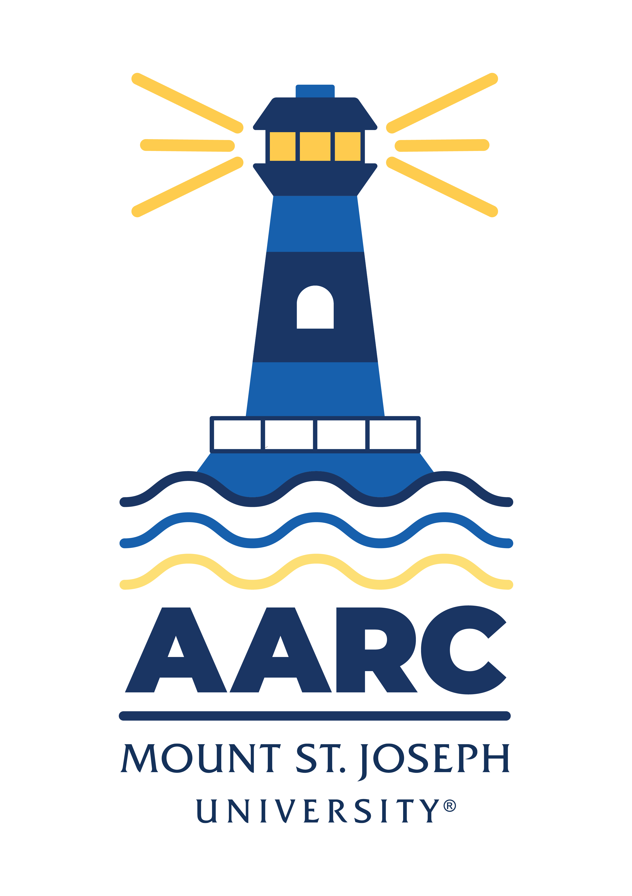
  - Newsletter— January 30, 2025

GOT A QUESTION? ask advising.

The Academic Advising Resource Center (AARC) is located in the Conlan Center, around the corner from the Registrar Office. Our team is here to help you any and all academic or advising questions. Drop-ins are welcome!

important TIPS & deadlines

As you get deeper into your classes, remember you can reach out to the Learning Center for assistance. It’s easy to do. Just email them: learning.center@msj.edu. Or drop by their office in the first floor hallway of Seton, called the Thrailkill Hallway of Success. Asking for help is a sign of strength, remember, not a sign of weakness.

If you’re not certain the major you’re currently in is right for you, come talk to an advisor in the Advising Center (advising@msj.edu) or walk right in for a chat. We’re unbiased and happy to help you figure out a plan that works for you, your interests, your academic, life, and career goals. We’re happy to help you think through your options!

If you need to drop a class, you’ll need to submit an add/drop form to the registrar’s office. The form is attached. The deadline to drop a course without a “W” on your transcript is February 7. There’s still time to decide, but be prepared to print the form and get the necessary signatures by the deadline if you do decide to drop a class.

life hacks with bpw

Q: Isn’t popcorn awesome?

A: Yes, it is. But “popcorn brain” is not. “Popcorn brain” describes distracted states of mind in our digital age. If throughout the day you continuously check social media, cruise the internet, stream content, check your email, text, query Siri, etc., chances are your thoughts are bouncing around inside your head like corn in a kettle. If you feel in a fog, or your memory stinks, or you’re always out-of-step cognitively, popcorn brain could be the culprit.

Another phrase to consider is “time confetti,” which refers more-or-less to the shredding of our linear, organized experience of time that occurs when we distract ourselves or multi-task. A recent study found that people during the pandemic checked their email an average of 72 times a day. Think about that. That’s nearly 5 times an hour. If every 12 minutes you’re distracted by your inbox, how can you expect to focus your attention on longer-term tasks in meaningful, in-depth ways? We all know attention spans have shrunk dramatically in the last 20-40 years, but do we ever take a hard look in the mirror to ask ourselves how we’re contributing to our own attentive decline?

A friend of mine used his phone to track his social media usage for a month, and he was shocked to discover he’d spent nearly 24 hours each week on Instagram. “That’s an entire day of my life,” he said, “each week.” It freaked him out. He’s a therapist, so it goes to show no one (bpw included) is immune to addictive behaviors of distraction.

The answer, of course, isn’t to toss your smart phone, to stop watching Key & Peele, or to deny yourself delightful Will Ferrell memes or Ariana Grande’s musical impersonations. But maybe let’s be honest with ourselves about our technology use, and how often—and when—we’re clicking, scanning, checking, liking, scrolling, etc. Start small, and see if each day, each week, you can claim back 10-15 minutes of your life. If you only had 15 minutes to live, would you spend it checking email, googling “Johnny Depp Amber Heart Trial,” or doom-scrolling?

“What is it you plan to do,” asked poet Mary Oliver, “with your one wild and precious life?” Every minute matters.

*To learn more about time confetti and ways it might be stealing your life out from under you, click here.

**For tips on resisting popcorn brain and setting boundaries with technology, click here.

LIBRARY SUPPORT

Looking for a fun popular fiction book to read and all of MSJ Library’s copies are checked out or the MSJ Library doesn’t have a copy? Never fear, SearchOhio and OhioLink are here! SearchOhio and OhioLink are two library consortia made up of public libraries and academic libraries across the state of Ohio who share materials. You can view and request items from these catalogs. These materials come in the mail, so it takes a few business days for them to arrive at MSJ Library. You’ll receive an email notification once they’re ready for pick-up.

Further step-by-step instructions are on the library’s website. Please speak with a librarian if you need assistance with requesting a book or other material from SearchOhio or OhioLink.

Wellness Tips

Today, take a moment to check in with yourself. Wellness is about more than physical or mental health—it’s about finding balance in every aspect of life. Whether it’s dedicating time to self-care, connecting with a friend, or simply pausing to take a deep breath, every small step makes a difference.

Here are a few tips to support your wellness journey this week:

- Move Your Body: Enjoy a short walk, stretch, or dance to elevate your mood.
- Stay Hydrated: Keep a water bottle nearby and sip throughout the day.
- Unplug: Take a break from screens and reconnect with the world around you.

Wellness is a journey, not a destination—what will you focus on today?

Explore more wellness resources on our website.

KATE’S CORNER (academic survival tips)

Contact kathryn.mitchell@msj.edu for info about Mount 101/102 or for more tips about how to start your semester off strong this year!

FOLLOW US ON INSTAGrAM!

Keep up with crucial dates and info about advising by following msj_advising on Instagram. And win free stuff!

